
A 10
Sreenidhi Institute of Science & Technology
(An Autonomous Institution)
Code No: 102SE15
M. TECH. I – Year II – Semester Examinations, August/September, 2011 (Regular)
PRINCIPLES OF QUANTUM COMPUTING (SOFTWARE ENGINEERING)

Time: 3 Hours Max. Marks : 60

Note : No additional answer sheets will be provided.

* * * * *
Part-A (Objective Type)
Max.Marks:10
Answer all the QUESTIONS.

In the figures below the input states are given. Write down the final state at the appropriate, qubit (row) in the right hand side of each figure (1 mark each)

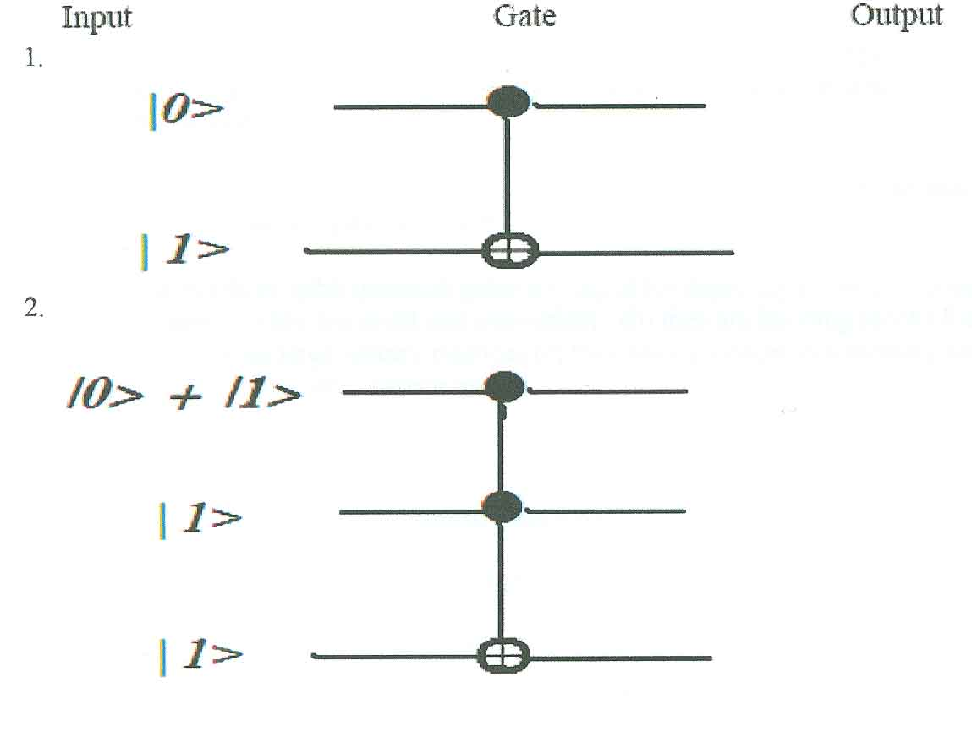
1.

2.

3. If on a quantum mechanical system, a single measurement is made of a
physical entity S for which the Hermitain operator is S_{op} then the measured
value will be:
(a) Some eigenvalue of S_{op}
(b) Average of any two or more eigenvalues of S_{op}
(c) Any value depending on the state of the quantum system.

4. Suppose |Ψ> is the state of a single qubit system, and suppose |Ψ> is normalized
to unity (ie |<Ψ|Ψ>|=1, then how many degrees of freedom the state |Ψ> can
have?( excluding an overall phase factor). Give reasons for your answer.

5. Write down the 2 by 2 Unitary Matrices for the Pauli X matrix.

6. Write down the 2 X 2 Unitary Matrices for the Hadamard Gate H.

7. If the energy of a quantum system is measured at a certain time, then the
uncertainty in Energy and time are ΔE , Δt then ΔE at will be:
(a) always smaller than h/4π (b) always greater than h/4π
(c ) always greater than or equal to h/4π (d) can be anything

8. If a matrix A is given by the expression: A = e^{iB} then A will be an unitary matrix if and only if,
(a) B is unitary, (b) B is symmetric (c) B is hermetian (d) B is real

9. Explain the following statement: "A quantum computer is more like an analog computer than a digital computer".

10. Two and three qubit quantum gates are useful for depicting a quantum computer because
(a) they are small and convenient
(b) they are building blocks for representing large unitary matrices
(c) they are equivalent to a memory bit
(d) they are the only known gates.

Part – B (Subjective Type)
Max. Marks: 50

Answer any Five. All questions carry equal marks.

1. (a) Write down the four (4) postulates of quantum mechanics and briefly explain their relevance in understanding and predicting the behaviour of small (quantum) systems.

(b) Write down the Schrodinger equation for the Infinite Square well (for one
dimension); solve it, and obtain the energy levels and obtain the eigen-functions.
Show that the eigen-functions are orthogonal to each other.

2. (a) What is Heisenberg's uncertainty principle? Write a brief essay on how it has changed the classical view of the physical world.

(b) (i) Show from Schrodinger's equation, that the state Ψ (t₀) of a system at time t₀, is connected to the state Ψ (t₁) at time t₁ , by an Unitary operator U(t₁, t₀) VIZ.
Ψ (t₁) = U(t₁, t₀) Ψ (t₀). Derive an expression for U(t₁, t₀).

(ii) Given that t₂ > t₁ > t₀, prove:
What, according to you, is the significance of the above equation?

3 . (a) Describe the Bloch Representation of a qubit and its usefulness (draw figures)
(b) Describe the method of obtaining the Fourier Series of a one dimension
function, f(t), and the method of the classical Fourier (integral) Transform.

4. (a) Clearly State Deutsch's algorithm and draw the complete quantum circuit. Then clearly demonstrate how quantum computers can outperform classical computers by implementing Deutsch's Algorithm.

(b) Briefly explain how the above Deutsch's algorithm is generalized to Deutsch-
Jozsa algorithm.

5. Describe completely the Quantum Fourier transform and its implementation by
using suitable Controlled gates, Hadamard gates and R-gates. Finally, draw the
figure for the complete Quantum Fourier transform circuit.

6. (a) Describe briefly the guiding principles and the conditions necessary for quantum computation to be possible.

(b) Describe briefly ONE of the following:

(i) The harmonic oscillator quantum computer.
OR

(ii) The optical photon quantum computer.

7. Write Short Notes on any TWO of the following:

(i) Shor's algorithm for the factorization of a composite integer.
(ii) Quantum cryptography.

(iii) The EPR pairs and the Bell states.

-- 00 -- 00 --

